**Analyze the problem:**

**Algorithm:**

1. Start the program.
2. Variable declaration for n, i, x, y, equation_1, equation_2, region_1, region_2, region_3, region_4.
3. Enter the value for n
4. Start array and loop: i=0; i<n; i++
   1. Enter the value for x and y
   2. If equation_1 < = 1 and equation_2 > 3 is true then increase region_1; if false go to next condition.
   3. If equation_1 < = 1 and equation_2 < = 3 is true then increase region_2 ; if false go to next condition.
   4. If equation_1 > 1 and equation_2 < = 3 is true then increase region_3 ; if false go to next condition.
   5. If equation_1 > 1 and equation_2 > 3 is true then increase region_4 and increase the value for i.
   6. i = i + +
5. Print the region_1, region_2, region_3, region_4
6. End the program.

**Flowchart:**

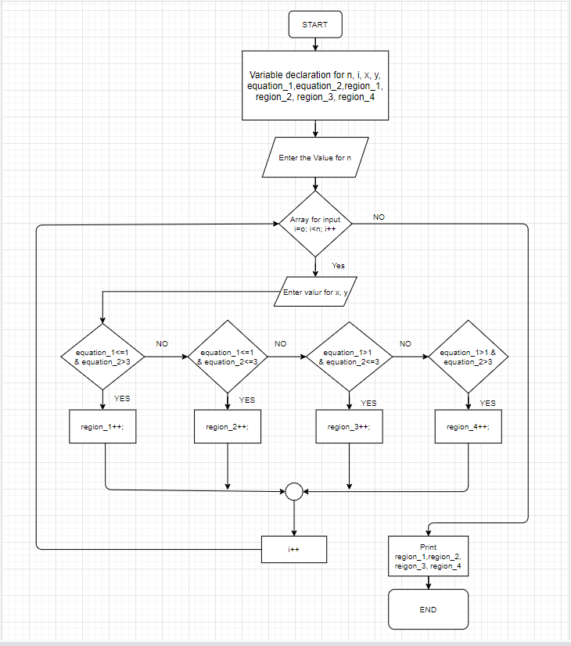

**Implementation:**

using System;

namespace Asignment_8050

{

class Program

{

static void Main(string[] args)

{

Console.WriteLine("Enter the value of N :");

int n = int.Parse(Console.ReadLine());

//initiate the value of regions to 0!!!

int region_1 = 0;

int region_2 = 0;

int region_3 = 0;

int region_4 = 0;

//Array to take input value for x,y according to N!!!

int[] x = new int[n];

int[] y = new int[n];

for (int i = 0; i < n; i++)

{

Console.WriteLine("Please enter the value of x :");

x[i] = int.Parse(Console.ReadLine());

Console.WriteLine("Please enter the value of y :");

y[i] = int.Parse(Console.ReadLine());

}

//loop for checking x and y value with equations!!!

for (int i = 0; i < n; i++)

{

double equation_1 = Math.Pow(x[i] - 2, 2) + Math.Pow(y[i] - 2, 2);

double equation_2 = x[i] + y[i];

if (equation_1 <= 1 && equation_2 > 3)

{

Console.WriteLine("({0},{1}) represent the region 1", x[i], y[i]);

region_1++;

}

if (equation_1 <= 1 && equation_2 <= 3)

{

Console.WriteLine("({0},{1}) represent the region 2", x[i], y[i]);

region_2++;

}

if (equation_1 > 1 && equation_2 <= 3)

{

Console.WriteLine("({0},{1}) represent the region 3", x[i], y[i]);

region_3++;

}

if (equation_1 > 1 && equation_2 > 3)

{

Console.WriteLine("({0},{1}) represent the region 4", x[i], y[i]);

region_4++;

}

}

Console.WriteLine("For Region 1 : {0}, Region 2 : {1}, Region 3 : {2}, Region 4 : {3}", region_1, region_2, region_3, region_4);

Console.WriteLine("-------------------------------------------------------------");

}

}

}

**Testing and post analyses:**

|  |  |  |  |  |
| --- | --- | --- | --- | --- |
| Point | X | Y | Result | The purpose of the test |
| 1 | 2 | 1 | Region 2 | Displaying positive quadrant. |
| 2 | -1 | -5 | Region 3 | Accept both negative quadrants. |
| 3 | 1.3 | -5.3 | Error | Does not accept decimal values. |
| 4 | a | b | Error | Does not accept latters. |
| 5 | 5 | -9 | Region 3 | Accept one positive and one negative value. |
| 6 | 3 | 2 | Region 1 | Displaying positive quadrant in region 1. |
| 7 | $ | % | Error | Does not accept any special character. |
| 8 | - | - | Error | Does not accept any empty values. |
| 9 | a | 2 | Error | Does not accept one latter and one value. |
| 10 | -1 | 2 | Region 3 | Accept one negative and one positive. |